**21.1.1**

Sofi, I need to talk to you

Hold on, **I have to take off my jacket. And then put on my hat first**. Where is Danielle?

That's why I want to talk to you. She can't come in today

Do you know why?

I think it because she doesn't like Nadi

**No one likes Nady. But This is the third day Danielle isn't at work.**

On wenesday night, Nadi and Danielle on Nadi's office, and then there was a fight. It was loud

Oh no, That's not good

**yep, It's bad. But nothing we can do about it**

You are right**! She's not here to make soup and salad for dinner**, so I need to make it now. What kind of soup do you want me to make today? Vegetable? **I can make this soup, but I need your help with the ingredients**

**Let's me wash my hands, and then I can help you**

First, **Can you get me some pots and pans?**

Yep! **where is the pots and pans in here?**

Sorry! **I want to make the soup first. And then we can make the salad**

Where ingredients do we need for the soup?

**Can you give me one box of onions?**

Here are the onion

**Can you give me one bag of rice?**

**Here is one bag of rice**

Thanks. **Can you give me 4 jars of peppers?**

I can. **Here are 4 jars of peppers**

**Can you give me 5 can of tomato?**

Can you give me a list of ingredients, so I can give everything in one trip

Yes, I can. Here is a list of ingredients

**Thank you. Here are they ingredients. A things of that . 3 bages of this stuff. A bag of these. A Bag of these . and a package of that stuff. And 5 can of tomates**

Thank you, Dieago

Why does Dieago think Danielle isn't at work?

-> He thinsk Danielle doesn't like Nadi

What was the problen on Wednesday night with Nadi and Danielle?

-> There was a loud fight.

Danielle is not in, so Sofi must **make the soup and salad**

Who does Sifi ask to help make the soup?

-> Dieago

Dieago helps Sofi by **getting the ingredients**

Why does Diego adk for a list of ingredients?

-> He wants to get everything at the same time

**Practice**

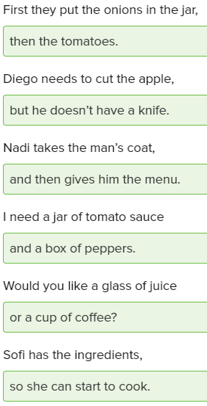

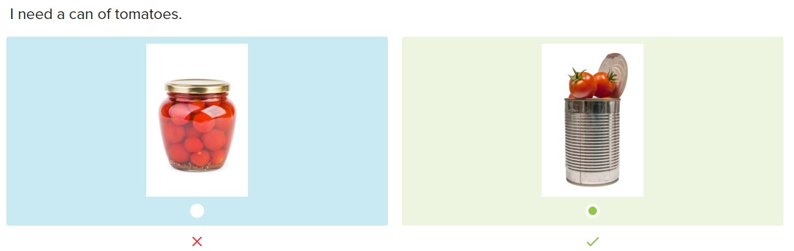

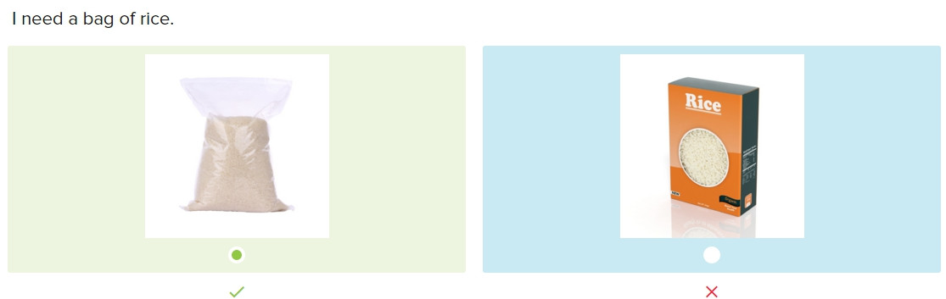

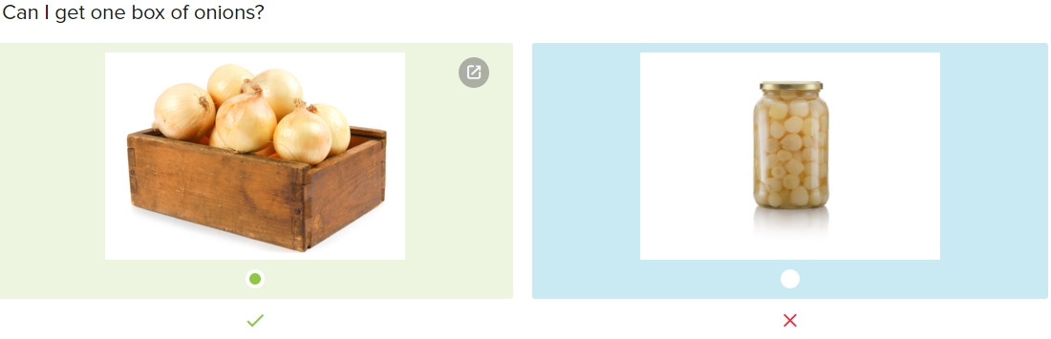

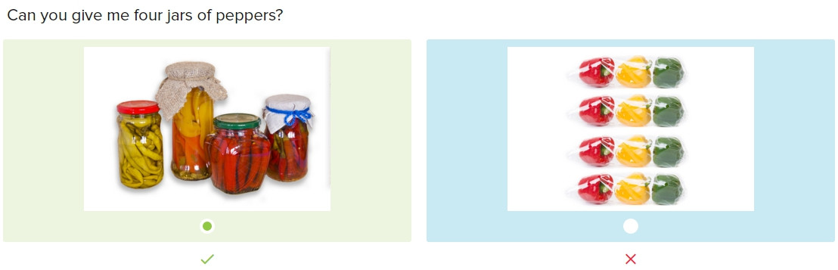

Skills practice

Diego, can you wash the pots and pans please?

Sure. I can wash them now

Thanks! When you finish, can you help me make soup?

The pots and pans are clean, so what do you need for the soup?

First, I need a box of onions and two jars of peppers

Here is a box of onions, but I can’t find the peppers

Oh, right, we don’t have peppers, so can you go to the store?

Okay. The Food Shop or The Green store?

The Green Store, and can you get a bag of rice, please?

I’m back, Sofi. Here is the bag of rice and then here are the jars of the peppers

**Conversation**

Diego, I need to make salad, can you give me the recipe for the salad

Sure, here’s a recipe

Thanks, can you get me a box of lettuce?

Here’s a box of lettuce, then do you need anything else?

Yes, I need 4 jars of salad dressing, please

Here are 4 jars of salad dressing

Thank you, and then I need a bag of onions

The bag of onions for you, so what do you need next?

Can you make salad, Diego?

Yes, I can Sofi, and then I need to go home

**Exercise**

I don’t have a car, **so** I take the bus to school

Here is your juice. **Can you give me** your glass please?

What can I get for you?

**-> I’d like two glasses of milk, please**

I’m very hungry because **I was busy at lunch**

A **box** of onions

We can shop now, **then** we can eat lunch later

**Here are** you vegetables. Enjoy your meal!

Can we have two **bowls** of soup?

-> Here is your soup

**Can you give me** some bread please?

-> Sorry. There’s no more bread

**21.1.2**

Where is Danielle?

I don’t know

I need to talk to her

She’s not here… Danielle

You start at 9 in the morning, not 6 in the evening

**Nadi , she can explain**

**I’m sorry, but I do have an explaination**, this morning my daughter was sick. We _ the doctor until this evening

You can’t work when you want to, you work when I tell you to work require you to be on time..for work

Yes, I know the requirement

Nadi , her daughter was sick

Silent, Sofi! **This discussion is between Danielle and me**…not you. **This is a management problem**

You’re right. **Let’s discuss how poorly you manage the restaurant**

It’s the kitchen you **poorly manage** it. And need then you chef. Who can do work I tell her to do. Today, it’s your last day at this restaurant

You fire me? How can you left me?

Yes, I’m. Not hard to fine your **replacement** place for you

Can you **punish** me why that fire me?

No, that’s your **punishment**

Fine, I don’t want to work for you. I quit! And I want my last check

I can send you your last check in the mail. Now leave!

I’m sorry, Sofi. Good luck with anything

What do you looking at? I have to food to cook

Why is Nadi mad at Danielle?

-> Danielle is late for work

Why does Sofi say something to Nadi?

-> She wants to help Danielle

It’s Danielle’s last day because Nadi is angry with her

What is the last thing Danielle asks for before she leaves?

-> Her money

**Practice**

What are the **requirements** for the job?

Can you **replace** the old lights with the new lights?

The teacher can give a short **explanation** on how to do the homework

Do your parents **punish** you when you do a bad thing?

The sick children require **special** help

I’m sorry I’m late. I can **explain**

It is very hard to find a good **replacement** for a head chef

Firing someone for being late is a big **punishment**

**Skill Practice**

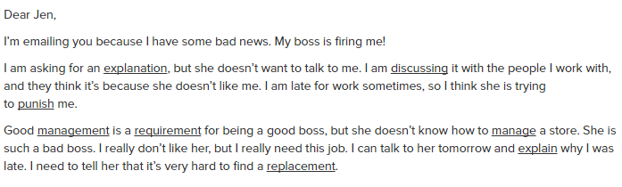

An explanation is something you say to help a person understand

Discussing means talking

Why would a boss punish his/her employee?

-> The employee misses many meetings

A person who is good at management is good at business

A requirement is a thing that is needed

What is something a person can manage?

-> A sports team

Explain means tell

You need a replacement when someone leaves his/her job